**Loans & Birth/Death Rate Data Warehouse Proposal**

***Finding the Correlation Between Loans and Birth/Death Rate***

**Group Members**

**Victor Ou** [**victor102496@gmail.com**](mailto:victor102496@gmail.com)

**Haonan Ou** [**hn737433241@gmail.com**](mailto:hn737433241@gmail.com)

**Soohun Han** [**hsh804@gmail.com**](mailto:hsh804@gmail.com)

***CIS4400 – CMWA - Group 2***

**Project Description**

Our intended project revolves around the effects loans may have on birth rates and mortality rate in New York. The economic environment over the past decade has forced many individuals and families to take out loans to either make ends meet or to invest in different opportunities. By analyzing annual birth rates with respect to continuous loan data, we hope to find trends that may help to paint an interesting narrative. Regarding the mortality rate, we want to specifically focus on deaths that occur in an unnatural manner, such as deaths relating to firearms, alcohol, and suicides. These unnatural occurrences, while morbid, may provide an insight on the effects loans can have on an individual’s mental health.

**Information Needs**

Dataset source containing information on birth rates by age/race/gender spanning over years

Dataset source containing information on mortality rates by age/race/gender spanning over years

Continuous loan data over the span of multiple years containing totals for multiple types of loans.

**KPI’s Documentation**

By dividing the total number of births per year and totaling balances of loans in each category per year starting from 2007 - 2014: auto loan, HELOC, credit card, and student loan, we can find ratios for each year. The same can be done to the specific categories of unnatural deaths: firearm, alcohol, and suicide. Along with this, we can also aggregate the balances of each loan categories: auto loan, HELOC, credit card, and student loan per year as well as the total dollar amount for every loan.

**Ratios**

Birthrate to auto loan ratio

Birthrate to HELOC ratio

Birthrate to Credit card ratio

Birthrate to Student loan ratio

Firearm death to auto loan ratio

Firearm death to HELOC ratio

Firearm death to Credit card ratio

Firearm death to Student loan ratio

Alcohol death to auto loan ratio

Alcohol death to HELOC ratio

Alcohol death to Credit card ratio

Alcohol death to Student loan ratio

Suicide to auto loan ratio

Suicide to HELOC ratio

Suicide to Credit card ratio

Suicideto Student loan ratio

**Balances**

Total Dollar Balance of Loans  
Total Auto loan balance

Total HELOC balance  
Total Credit Card Balance  
Total Student loan balance

**Dimension and Facts**

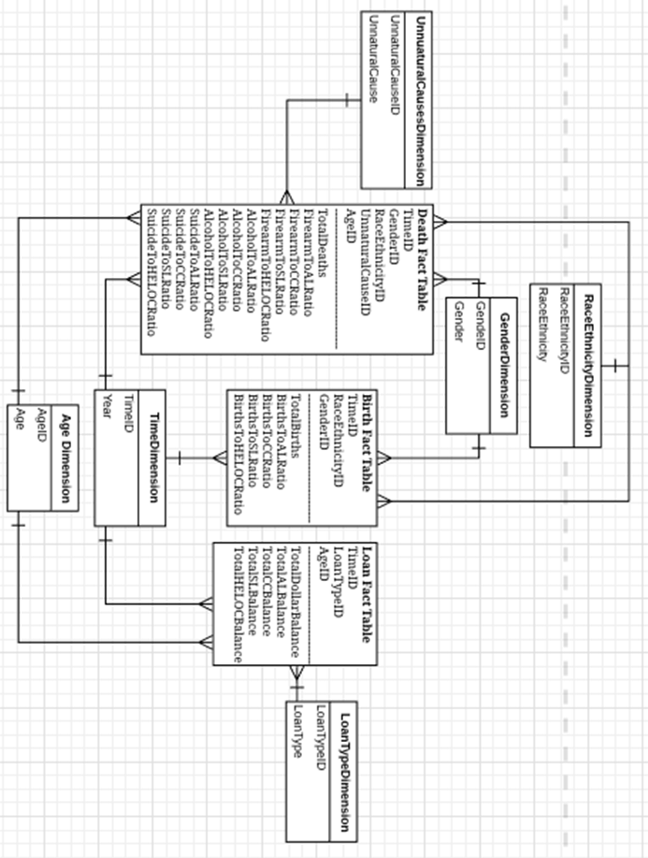

**Datasets Used**

*Debt data for years 04-14*

<https://data.world/finance/student-loan-debt>

*Percent Live Births by Infant Sex and Mother’s Race/Ethnicity for New York City, 2007-2014*

<https://data.cityofnewyork.us/Health/Natality/wffy-3iyg>

*Vital_Statistics_Suicide_Deaths_by_Age-Group__Race_Ethnicity__Resident_County__Region_and_Gender__Beginning_2003*

[https://healthdata.gov/dataset/vital-statistics-suicide-deaths-age-group-raceethnicity-resident-county-region-and-gender-13#{view-graph:{graphOptions:{hooks:{processOffset:{},bindEvents:{}}}},graphOptions:{hooks:{processOffset:{},bindEvents:{}}},view-grid:{columnsWidth:[{column:!Firearm++Deaths,width:268},{column:!Alcohol-Related++Deaths,width:250},{column:!Suicide++Deaths,width:225](https://healthdata.gov/dataset/vital-statistics-suicide-deaths-age-group-raceethnicity-resident-county-region-and-gender-13#%7Bview-graph:%7BgraphOptions:%7Bhooks:%7BprocessOffset:%7B%7D,bindEvents:%7B%7D%7D%7D%7D,graphOptions:%7Bhooks:%7BprocessOffset:%7B%7D,bindEvents:%7B%7D%7D%7D,view-grid:%7BcolumnsWidth:%5B%7Bcolumn:!Firearm++Deaths,width:268%7D,%7Bcolumn:!Alcohol-Related++Deaths,width:250%7D,%7Bcolumn:!Suicide++Deaths,width:225)}]}}